 User Account Creation Script V3
The newest version of the User Account Creation Script has a couple of improvements
- Can mailbox enable a user account
- Prompts for admin credentials and doesn’t require run as a different user anymore
- Fixed the Wine Trends error to include inc in the e-mail address
- Can be ran on your laptop, no logging into servers required

How to use the script
- Run the usercreatev3.exe file
- UAC will prompt you just hit Yes
- It will first ask you if you want to create a user, setup a user’s mailbox, or exit
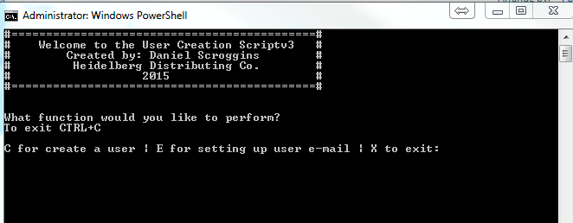
- Click here to jump to User Creation instructions
- Click here to jump to e-mail instructions

User Creation
- The script will prompt you to enter in your Domain Admin credentials
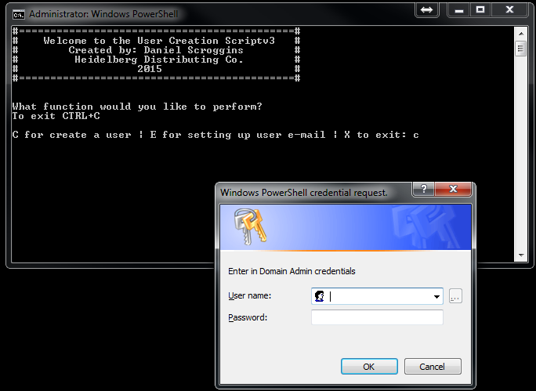

- Follow the prompts to enter in the user information
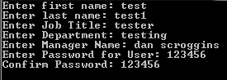
- Select the applicable company name (NOTE: This will set the users primary e-mail address in addition to Company name)
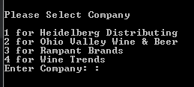

- Select the applicable office location (NOTE: This will set the office name,street address, city, state, and zip)
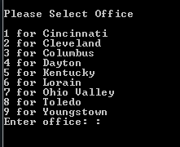
- Confirm if the listed information is correct
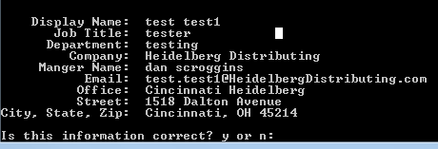
- If you hit no you be directed to the below screen to select what you want to correct
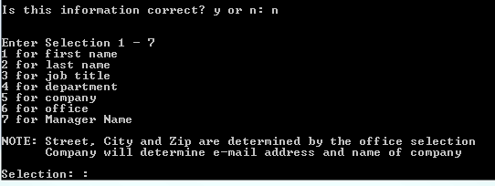

- If you hit yes the information is commited and the user will be created in the domain
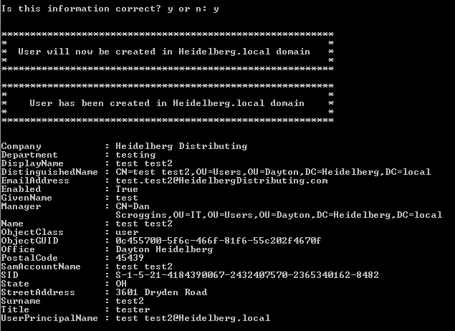
- Next you will be prompted if you would like to move on to setting up the user’s mailbox. You will be notified that you need to have the correct permissions in order to do this.
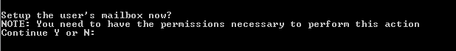
- If you hit yes then it will move on the next section User E-Mail Setup
- It will prompt you to Enter in the user account (In this case I type in the account test test2). Normally you would type in the user’s firstname lastname as they would use to log into their email, laptop, desktop.
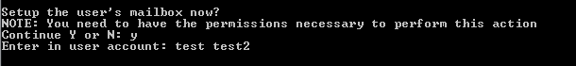

- The script will check to ensure the account is created on the OVADMIN domain controller. If it is found it will prompt you for your Exchange Admin credentials
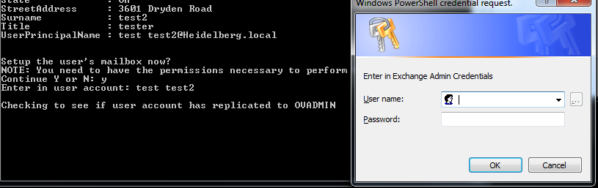
- The script will enable the user’s mailbox and add any aliases if necessary for WineTrendsInc, Rampant Brands, or Ohio Valley Wine and Beer.
- It will then prompt you to ask if you need to perform additonal tasks.
User E-Mail Setup
- The script will prompt to see if the user account has already been created in the domain.
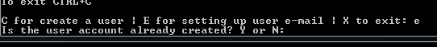
- If you select no it will notify you that the user account needs to be created first and prompt you if you would like to create it now.
- Yes will send you to create the user, No will exit the script
- If you select yes for the user account is already created then you will follow the same process as here
If you encounter any issues with the script please contact me
Name: Daniel Scroggins
Email: dan.scroggins@heidelbergdistributing.com
Spark: dscroggins
Cell: 937-824-0987

